# Sossusvlei getway

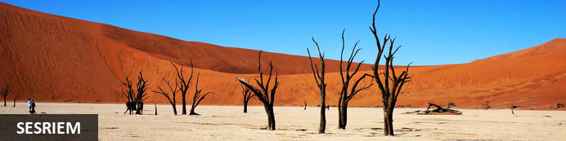

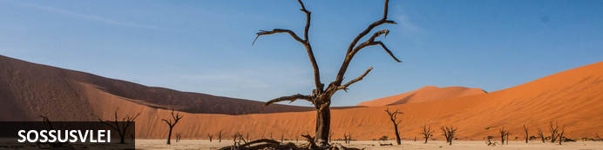

# Sossusvlei getway

*Sesriem - Sossusvlei*  
*3 Days / 2 Nights*  
  
*Date of Issue: 29 February 2024*

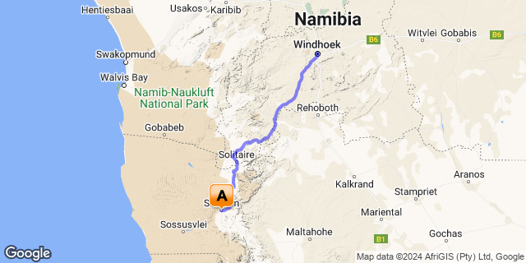

## Introduction

|  |  |  |  |  |
| --- | --- | --- | --- | --- |
| **Start** | **Accommodation** | **Destination** | **Basis** | **Duration** |
| Day 1 | Sossusvlei Lodge | Sesriem | D,B&B | **2 Nights** |

**Key**  
B&B: Bed and Breakfast. D,B&B: Dinner, Bed and Breakfast

## Day 1: Sossusvlei Lodge, Sesriem

### Sesriem

As there is no accommodation at Sossusvlei, visitors to this desert wilderness are likely to end up staying at Sesriem, 65 kilometres away, where camps and lodges serve as a base from which to explore the dunes. Sesriem Canyon, a deep chasm carved through the rocks by water, is a striking natural feature of the area that is best explored on foot. Stony walls rise up sharply on both sides of the canyon, while birds roost in its crags and lizards dart along the ledges. The canyon’s name was coined when early settlers used it as a water source, using six lengths of leather (‘ses riem – six thongs) tied together to lower buckets into the water at the base of canyon.)

### Overnight: Sossusvlei Lodge

Situated at the Entrance Gate to the Namib Naukluft Park, Sossusvlei Lodge offers direct access to the towering red sand dunes, the famous pan of Sossusvlei, the scorched black trees of Dead Vlei and the remarkable depths of the Sesriem Canyon. The 45 individual luxurious accommodation units at Sossusvlei Lodge are carefully laid out to perfectly blend in with the magnificent surrounding natural environment. Each fully air-conditioned unit has a patio, en-suite bathroom with shower and a spacious bedroom under canvas with adobe-style plaster walls to give the visitor a distinctive sense of being close to nature. Experience the true art of Hospitality with the thoughtful touch of attentive staff to contribute to a truly memorable experience. Facilities include a sparkling pool, bar, beer garden and an al fresco terrace where one can enjoy exquisite food, award-winning wines and magnificent views of the floodlit waterhole. The Sossusvlei Lodge Adventure Centre provides a range of activities including Quad-Biking, Guided Excursions, Sun-downer Trips, Hot Air Ballooning, Scenic Flights and much more to explore the area’s natural beauty.

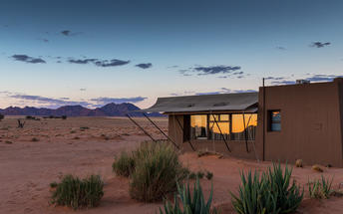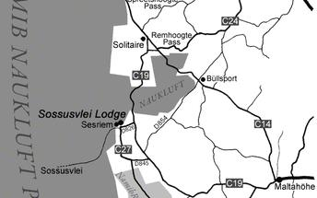

|  |
| --- |
| Directions - Windhoek Railway Station to Sossusvlei Lodge |
| **Distance:** 304.65km **Travel Time:** 4:08 hours |
| **GPS co-ordinates for Sossusvlei Lodge:** S 24° 29' 2.346" E 15° 48' 9.473" |
| * Head south (0.1 km)http://schemas.openxmlformats.org/drawingml/2006/picture * Turn left toward Independence Ave (71 m) * Turn left toward Independence Ave (51 m) * Turn right at the 1st cross street onto Independence Ave (0.2 km) * Turn right at the 1st cross street onto Bahnhof St (0.3 km) * Bahnhof St turns left and becomes Mandume (0.2 km) * Turn right onto John Meinert Street (0.1 km) * Slight left toward Hosea Kutako Dr/B1 (69 m) * Slight left onto Hosea Kutako Dr/B1 (3.8 km) * Turn right onto C26 (1.4 km) * At the roundabout, take the 1st exit onto Mandume Ndemufayo Ave/C26 (1.7 km) * At the roundabout, take the 2nd exit and stay on Mandume Ndemufayo Ave/C26Continue to follow C26 (101 km) * Turn left onto D1265 (30.0 km) * Merge onto D1261 (22.7 km) * Turn right onto D1275 (50.5 km) * Turn left onto C14 (9.3 km) * Turn right onto C19 (71.1 km) * Turn right onto D826 (11.6 km) * Turn rightDestination will be on the left (10 m) |

### Basis

Dinner, Bed and Breakfast

## Day 2: Sossusvlei Lodge, Sesriem

### Activities

|  |
| --- |
| Sossusvlei - The Vlei |

#### Sossusvlei - The Vlei

This is the vlei itself where, for now, the waters of the Tsauchab River disappear into the red sands of the Namib.

### Basis

Dinner, Bed and Breakfast

## Day 3: End of Itinerary

|  |
| --- |
| Directions - Sossusvlei Lodge to Windhoek Railway Station |
| **Distance:** 304.66km **Travel Time:** 4:06 hours |
| **GPS co-ordinates for Windhoek Railway Station:** S 22° 33' 25.428" E 17° 04' 54.416" |
| * Head south toward D826 (10 m)http://schemas.openxmlformats.org/drawingml/2006/picture * Turn left onto D826 (11.6 km) * Turn left onto C19/M36Continue to follow C19 (71.1 km) * Turn left onto C14 (9.3 km) * Turn right onto D1275 (50.5 km) * Turn left onto D1261 (22.7 km) * Continue straight onto D1265 (30.0 km) * Turn right onto C26 (101 km) * At the roundabout, take the 3rd exit onto Mandume Ndemufayo Ave/C26 (1.7 km) * At the roundabout, take the 2nd exit and stay on Mandume Ndemufayo Ave/C26 (1.4 km) * Turn left onto Hosea Kutako Dr/B1 (3.9 km) * Turn right onto John Meinert Street (0.1 km) * Turn left onto Mandume (0.2 km) * Turn right onto Bahnhof St (0.3 km) * Turn left onto Independence Ave (0.2 km) * Turn left at the 1st cross street at Korner Street (51 m) * Turn right (71 m) * Turn right (0.1 km) |

### Basis

Bed and Breakfast